PROJECT REPORT
Women's Clothing
Trends and Analysis in the Fashion Industry
Categorical Univariate Analysis
Frequency distributions | Dynamic encoding | Visual trends | Entropy importance

1. Executive Summary
This report presents a categorical univariate analysis of 23,486 women's clothing reviews. The work evaluates category frequencies, missingness, cardinality, encoding requirements and entropy-based distribution importance. Bar charts and pie charts were used for individual distributions, while stacked bar charts supported interpretation of recommendation trends across product groups.
The dataset is dominated by the General division (58.97%), Tops department (44.57%), Dresses class (26.91%) and five-star ratings (55.91%). Overall, 82.24% of reviews recommend the associated product. Rating has the highest normalized entropy score among the main analytical categories (75.36), while Division Name is comparatively concentrated (61.96). High-cardinality Clothing ID was encoded using frequency encoding to avoid creating 1,206 dummy variables.

2. Project Objective
The objective was to perform univariate analysis on categorical columns by creating frequency distributions, dynamically identifying and encoding high-cardinality categories, visualizing trends through bar, pie and stacked bar charts, and measuring category-distribution importance using Shannon entropy.

3. Dataset Overview
Dataset aspect | Value | Interpretation
Rows | 23,486 | Individual customer reviews
Columns | 11 | Original dataset fields
Duplicate rows | 0 | No duplicate removal required
Main categorical fields | 5 | Division, department, class, rating and recommendation
High-cardinality field | 1 | Clothing ID with 1,206 unique products
Free-text fields | 2 | Title and Review Text; excluded from category encoding

4. Data Preparation
A safe working copy was created so the original data remained unchanged. Fourteen missing entries in Division Name, Department Name and Class Name were assigned the explicit category 'Unknown'. Leading and trailing spaces were removed from text-based categories. Rating and Recommended IND were retained as categorical variables despite their integer storage type.
The index field 'no' and numerical fields Age and Positive Feedback Count were excluded from categorical analysis. Title and Review Text were treated as free text rather than nominal categories because their extremely high uniqueness represents natural language, not stable category labels.

5. Methodology
Method | Implementation
Frequency distribution | Count, percentage and cumulative percentage for every category
Cardinality classification | Low: <=10; Medium: 11-50; High: >50 unique categories
Rare-category treatment | Categories below 1% within medium-cardinality fields grouped as Other
Low-cardinality encoding | One-hot encoding
Medium-cardinality encoding | Rare grouping followed by one-hot encoding
High-cardinality encoding | Frequency encoding
Entropy importance | Normalized Shannon entropy converted to a 0-100 diversity score

5.1 Entropy measure
For a categorical variable X with category probabilities p_i, Shannon entropy was calculated as H(X) = -sum[p_i log2(p_i)]. The maximum possible entropy is log2(k), where k is the number of observed categories. Normalized entropy was computed as H(X)/log2(k), enabling comparison across variables with different category counts. The reported importance score is normalized entropy multiplied by 100.

5.2 Interpretation boundary
The entropy score measures category balance and diversity, not causal or predictive feature importance. A high score indicates that observations are spread more evenly across categories. Identifier fields can receive high entropy because they contain many unique values, even when their direct modeling value is limited.

6. Frequency Distribution Results
Column | Dominant category | Frequency | Share
Division Name | General | 13,850 | 58.97%
Department Name | Tops | 10,468 | 44.57%
Class Name | Dresses | 6,319 | 26.91%
Rating | 5 | 13,131 | 55.91%
Recommended IND | 1 (Recommended) | 19,314 | 82.24%
Clothing ID | 1078 | 1,024 | 4.36%
The dominant-category results show that the dataset is concentrated in a small number of commercially important groups. General and Tops account for the largest shares at their respective hierarchy levels. The very high share of five-star ratings and recommended reviews also indicates a positive-review skew.

7. Visual Analysis
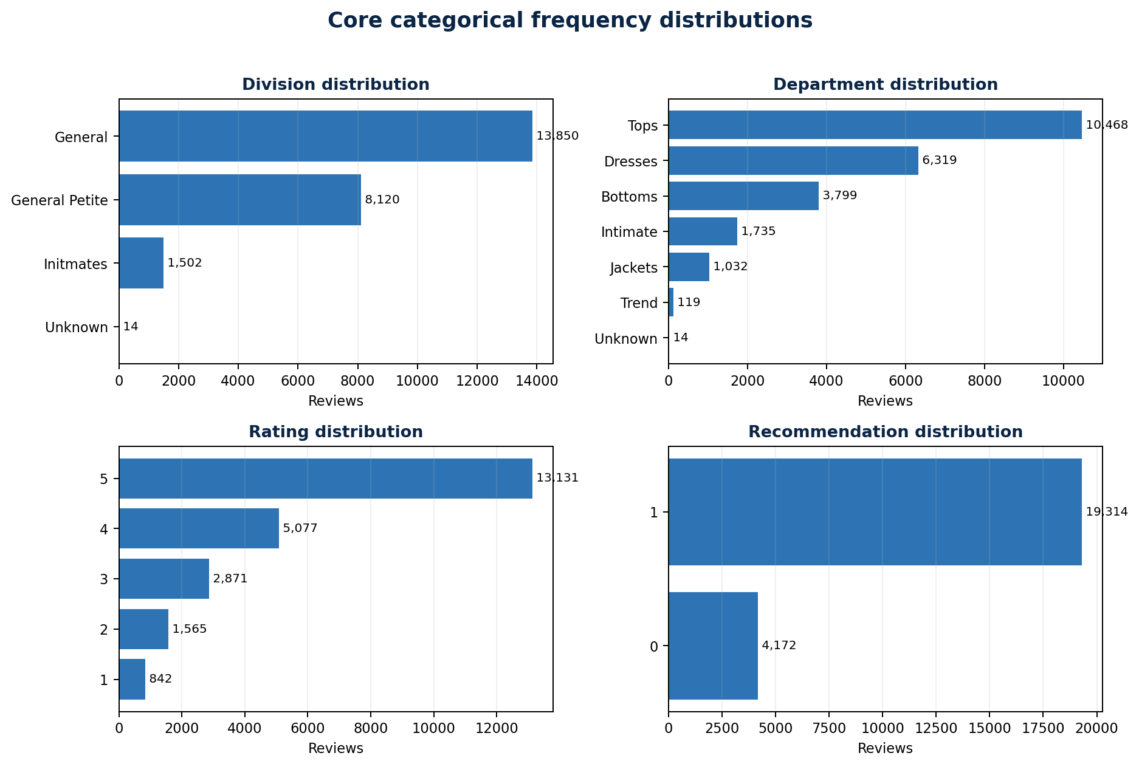
Figure 1. Core categorical frequency distributions
The charts confirm that the largest divisions and departments contribute substantially more reviews than smaller groups. Rating 5 and Recommended IND 1 dominate their respective distributions, while the product hierarchy becomes progressively more diverse from Division Name to Class Name.

7.1 Pie-chart suitability
Pie charts were used only for low-cardinality columns such as Division Name, Department Name, Rating and Recommended IND. Class Name and Clothing ID were excluded from pie visualization because 21 and 1,206 categories respectively would create cluttered, unreadable charts. This automatic restriction preserved interpretability.

8. Recommendation Trends
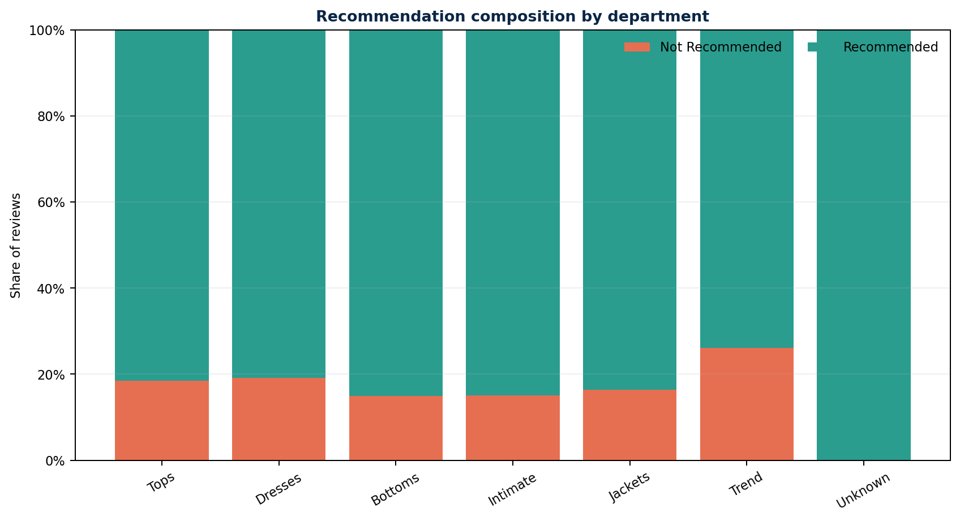
Figure 2. Percentage composition of recommendation status by department
Department | Recommended | Not recommended
Bottoms | 85.13% | 14.87%
Intimate | 85.01% | 14.99%
Jackets | 83.62% | 16.38%
Tops | 81.52% | 18.48%
Dresses | 80.82% | 19.18%
Trend | 73.95% | 26.05%
Bottoms and Intimate have the highest recommendation rates among departments with meaningful sample sizes. Trend has the lowest recommendation rate at 73.95%. The Unknown group shows 100% recommendation but contains only 14 records, so it should not be interpreted as a stable performance signal.

9. Rating and Recommendation
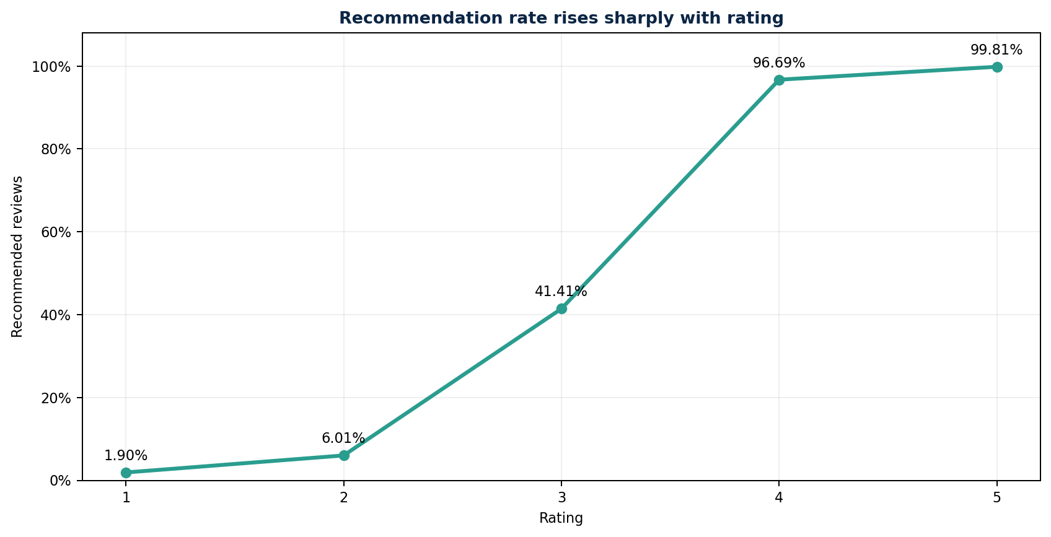
Figure 3. Recommendation rate by star rating
Rating | Recommended | Not recommended
5 | 99.81% | 0.19%
4 | 96.69% | 3.31%
3 | 41.41% | 58.59%
2 | 6.01% | 93.99%
1 | 1.90% | 98.10%
The relationship is strongly monotonic: recommendations are nearly universal for ratings 4 and 5, fall below half at rating 3, and become rare at ratings 1 and 2. Although the main task is univariate, this stacked comparison provides useful contextual validation of the category distributions.

10. Entropy-Based Category Importance
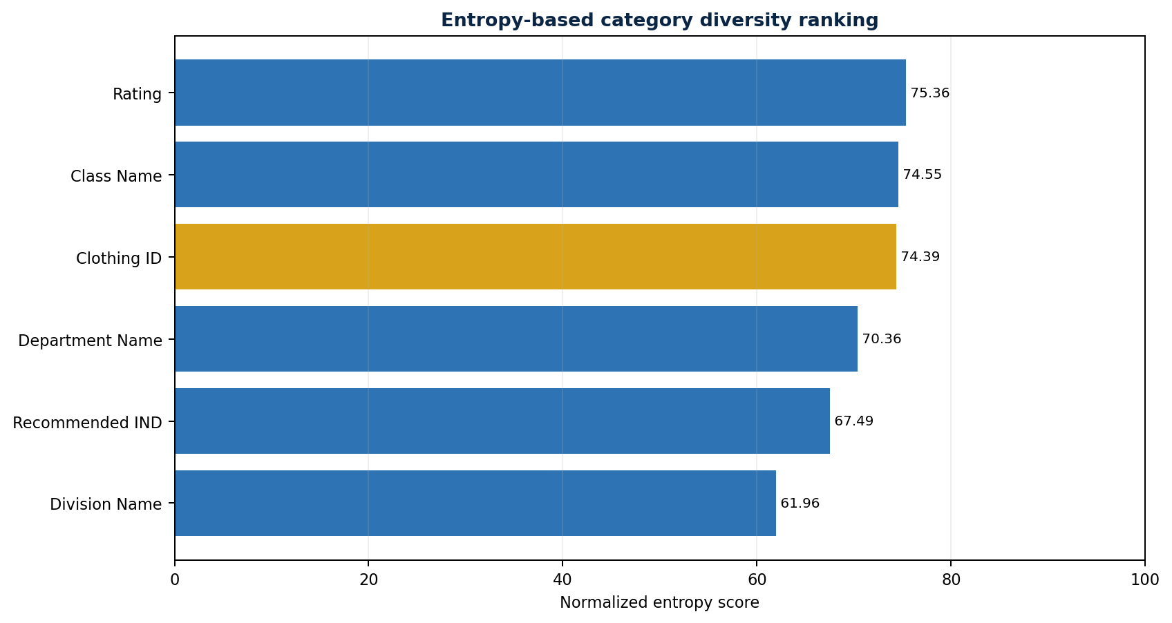
Figure 4. Normalized entropy ranking across analysed categorical fields
Column | Categories | Entropy | Score | Dominant category
Rating | 5 | 1.7499 | 75.36 | 5 (55.91%)
Class Name | 21 | 3.2743 | 74.55 | Dresses (26.91%)
Clothing ID | 1,206 | 7.6141 | 74.39 | 1078 (4.36%)
Department Name | 7 | 1.9751 | 70.36 | Tops (44.57%)
Recommended IND | 2 | 0.6749 | 67.49 | 1 (82.24%)
Division Name | 4 | 1.2391 | 61.96 | General (58.97%)
Rating achieved the highest normalized score at 75.36, followed closely by Class Name at 74.55. Clothing ID scored 74.39 because of its 1,206 unique product identifiers; this reflects diversity rather than predictive value. Division Name recorded the lowest score at 61.96 because General represents nearly three-fifths of all records.

11. Dynamic Encoding Strategy
Column | Categories | Cardinality | Selected method
Division Name | 4 | Low | One-hot encoding
Department Name | 7 | Low | One-hot encoding
Class Name | 21 | Medium | Rare grouping + one-hot encoding
Rating | 5 | Low | One-hot encoding
Recommended IND | 2 | Low | One-hot encoding
Clothing ID | 1,206 | High | Frequency encoding
One-hot encoding was selected for low-cardinality variables because it preserves category independence without imposing order. For Class Name, rare levels below 1% were consolidated before one-hot encoding to control sparse features. Clothing ID used frequency encoding so the representation remained compact and avoided 1,206 dummy variables. Label encoding was not used because it would create an artificial numerical order among nominal product identifiers.

12. Validation Results
Validation check | Result | Status
Original dataset rows | 23,486 | Passed
Cleaned categorical rows | 23,486 | Passed
Encoded dataset rows | 23,486 | Passed
Missing categorical values after cleaning | 0 | Passed
Missing values in encoded output | 0 | Passed
Duplicate original rows | 0 | Passed
All row counts were preserved throughout cleaning and encoding. The final cleaned and encoded categorical outputs contained no missing values, confirming that the pipeline completed without record loss.

13. Conclusion
The categorical univariate analysis successfully identified the dominant product groups, quantified category balance, handled missing category labels, selected encoding methods dynamically and produced interpretable visual summaries. The dataset contains a clear concentration in General, Tops, Dresses, high ratings and recommended products. Entropy results show moderate-to-high diversity across the analytical variables, while the encoding strategy balances information preservation with dimensional efficiency.
For future predictive modeling, Rating and Recommended IND should be treated carefully because of their strong conceptual relationship. Clothing ID frequency may provide a product-popularity signal, but the raw identifier should not be interpreted as an ordered numerical feature. Title and Review Text should be analysed separately with natural-language methods rather than categorical encoding.

14. Limitations
Entropy measures diversity rather than predictive contribution. Small categories can produce extreme percentages, so recommendation comparisons should be interpreted alongside sample size. The dataset also represents submitted reviews rather than the full customer population, which may introduce selection bias. Finally, the high proportion of positive ratings suggests class imbalance that should be addressed in later modeling work.

15. Deliverables
Output | Purpose
Cleaned categorical dataset | Missing labels resolved as Unknown
Cardinality summary | Unique counts and low/medium/high classification
Frequency distributions | Counts, percentages and cumulative percentages
Encoding report | Method selected for every analysed field
Entropy summary | Entropy, normalized score and category ranking
Encoded categorical dataset | Model-ready numerical representation
Stacked distribution tables | Recommendation composition by group

